

M.S. 287 Q - The Emerson School
108-35 167 Street, Queens, NY 11433

School Visit
December 12, 2025, 9:00 am
Olessia Bauer, CEC28 School Liaison Report
The tour was conducted by Assistant Principal Dahila Adams. Notes were taken by Olessia Bauer.
The school has received building renovation grants in 2025. The school has difficulty with tracking the grants’ details including responsible contractors, completion dates, and renovation details.
The projects are as follows:
- HVAC system installation sponsored by Reso A, budget is $550,000 (start date and other details are needed).
- Jamaica Neighborhood Plan (more details are needed)
- Gym renovation sponsored by Natasha Williams, budget is $2,000,000 (start date and other details are needed).
- Restroom upgrades sponsored by a Council Member, approved in November, budget is $1,500,000 (start date and other details are needed).
- Computer room - Reso A grant was received in November (more details are needed).
The school has old windows that do not open. The three-story building hosts three schools (J.H.S. 008, M.S. 287, and 28Q284 (third floor). The indoor temperature fluctuates from very cold on the first floor to alarmingly hot on the third floor during the same day. The staff and students on the third floor have experienced heat exhaustion requiring medical attention. New windows are needed for safety and health of everyone in the building.
The water fountains do not work. Some of them are filled with standing water.
Cafeteria and bathrooms are in poor condition. The spaces are old, the toilet seats are too low, and sinks get flooded. PTA and Parent coordinator do not have their own rooms. The auditorium has a big hole in the ceiling. Falling debris from the ceiling has caused evacuation of guests from the seats below the hole.

The three schools need educational grants to give the students a wider range of programs. In M.S. 287 the students enter 6th grade poorly prepared. Some of them need to learn phonics and other basics of elementary curricular. The students make good progresses through the year, but the teachers need more tools to bring the students to the district and city-wide levels of proficiency and academic excellence.

The list of programs (extracurricular activities) in M.S. 287 is short compared to other schools in D28: Dance, Homework Help, National Junior Honor Society, Restorative Circles, Saturday Academy, Student Council, Technology, Yearbook. M.S. 287 has partnered with two Project PIVOT partners to increase opportunities for students. As a result of these partnership the school was able to offer a visual arts and DJ program to students during the regular school day. M.S. 287 was also selected to be an Arts Fellows school this year, allowing for an additional $80,000 in funding to support after school theater programs.

According to the NYC School Survey, instruction and student performance are areas in need of improvement. In response, the school has made adjustments to the instructional program to better support its rapidly growing multilingual learner population, which increased from 12% of students in 2021 to 29% in 2024.
Outside The Building
Traffic and Safety concerns:
- One-way street is needed in front of the building. Parked cars restrict visibility and flow of traffic on a two-way street. Crossing the street is difficult with two-way traffic. The school applied for Open Street Program with the community board. However, because open streets programs must be supported by school staff (crossing guards cannot assist contractually) implementation has been delayed due to staffing issues.
- Dumping, abandoned cars, and a suspicious truck with candy advertisement have all been parked near the school for a while. The school made many 311 calls. Additional enforcement has been promised but has been inconsistent.

After the Visit Update
Emerson has been approved to open the first bilingual special education class in our district beginning in September 2026! This program will be taught in a combination of two languages—English and Spanish. Currently, 5th grade students who require this service must travel outside the district for 6th grade. Starting next September, they will no longer need to do so.
Photos From the Tour
This window is used as a display, because it doesn’t open.
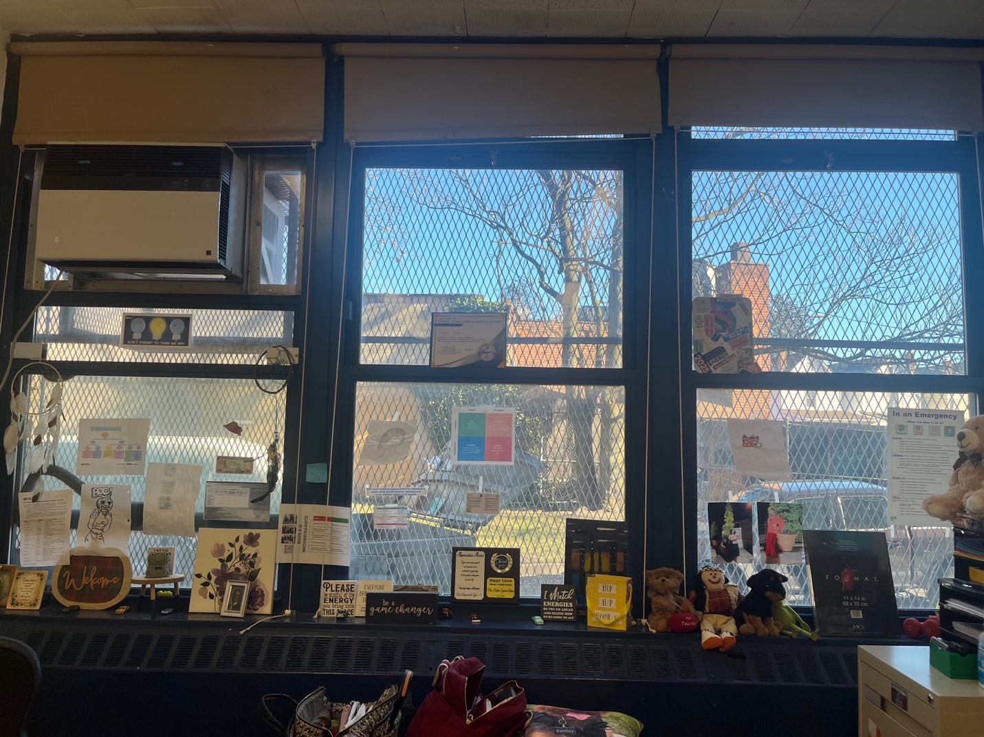

Auditorium (picture on the right), large hole in the ceiling picture on the left).
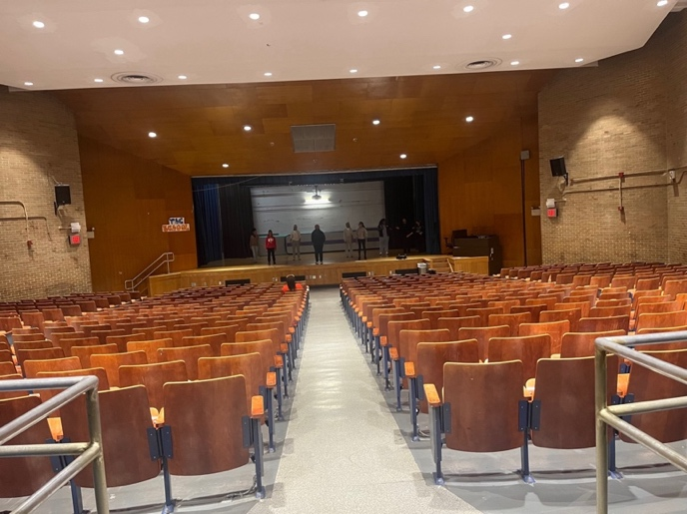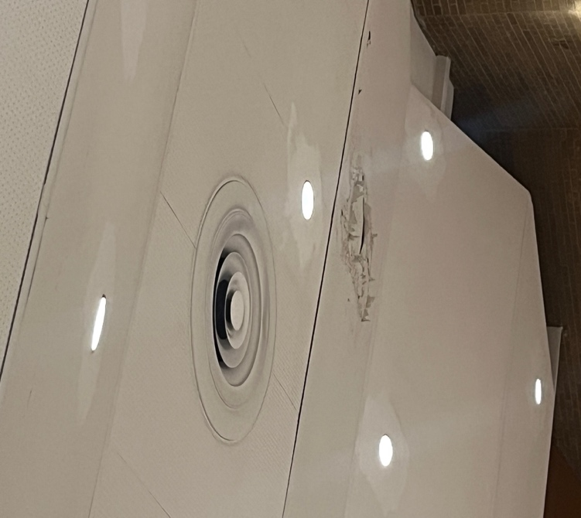

CEC28 liaisons from left to right: Olessia Bauer, Paquita Williams, and Kenya Townsend.
